# Problem 1 – Inside the Building

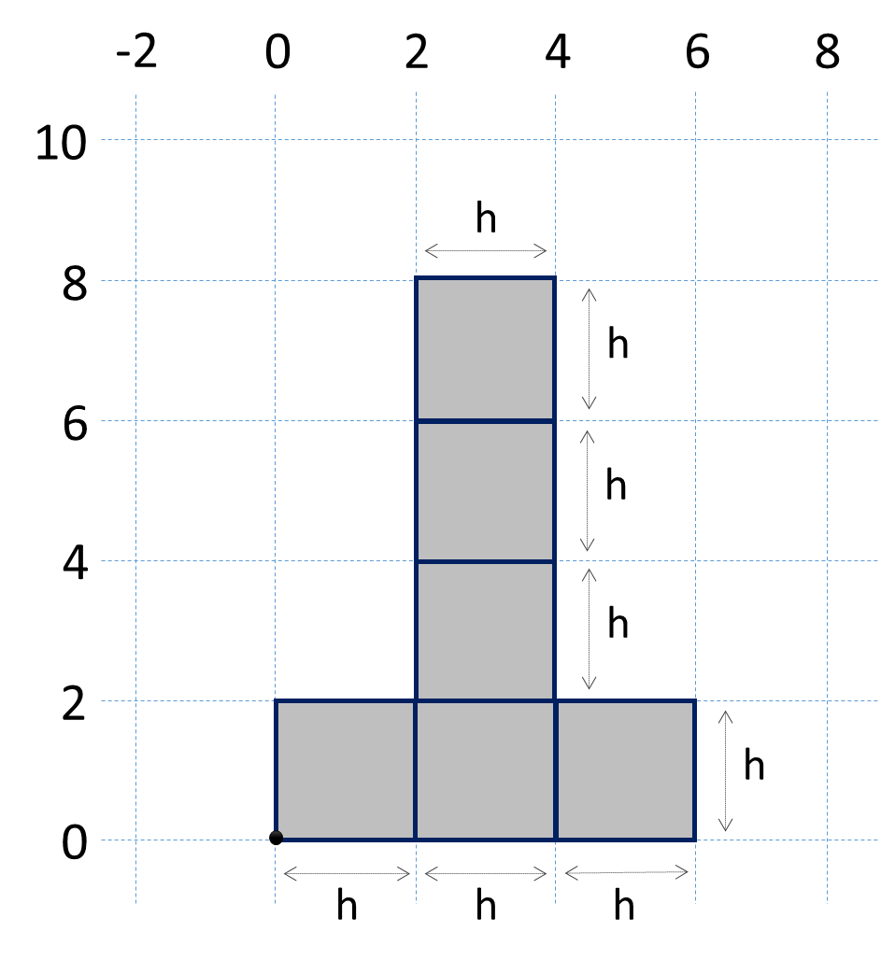In Absurdistan the **buildings** look like the figure on the right. They consist of **6 blocks of size h * h**. Their bottom-left corner is located at the coordinates (0, 0). See the figure (for h = 2) to get a better idea.

Write a program that enters a size **h** and 5 points {**x1**, **y1**},{**x2**, **y2**},{**x3**, **y3**},{**x4**, **y4**}, and {**x5**, **y5**} and prints for each of the points whether it is inside or outside of the building. Points at the building's border, like {0, 0}, are considered inside.

### Input

The input data should be read from the console.

* At the first line an integer number **h** specifying the **size** of the building will be given.
* At the next 10 lines the numbers **x1**, **y1**, **x2**, **y2**, **x3**, **y3**, **x4**, **y4**, **x5**, **y5** are given.

The input data will always be valid and in the format described. There is no need to check it explicitly.

### Output

The output should be printed on the console. It should consist of exactly 5 lines. At each line print either "**inside**" or "**outside**" depending of where each of the 5 input points are located.

### Constraints

* All numbers in the input will be integers in the range [-1000 … 1000].
* Allowed working time for your program: 0.1 seconds.
* Allowed memory: 16 MB.

### Examples

|  |  |  |  |  |  |  |
| --- | --- | --- | --- | --- | --- | --- |
| **Input** | **Output** | **Comments** |  | **Input** | **Output** | **Comments** |
| 2  3  10  0  6  2  2  3  1  6  0 | outside  outside  inside  inside  inside |  | 15  29  38  37  19  30  0  -4  7  13  57 | inside  outside  inside  outside  outside |  |